**Graph Transformation Model Description**

A graph transformation model includes a set of transformation rules. Each rule consists of a rule ***left-side, roles, application conditions and operations.***

The **rule left-side** describes the sub-graph which will be replaced by applying the transformation rule in the given original graph. The **roles** depict the existing roles and a newly arriving role in a configuration process. When the **application conditions** are fulfilled, the **operations** will be performed. A transformation rule is applied, when all operations are performed.

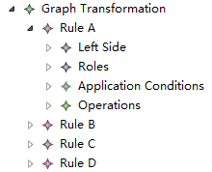

Figure 1 Graph Transformation Structure

As a graph, a **left-side** consists of a set of **nodes** and **edges**. A Node has an **input edge** and an **output edge**, whereas an edge has a s**ource node** and **target node**. With a name, the model editor can clearly show the relationship between the nodes and edges.

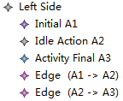

Figure 2 Transformation Rule Left Side

An **existing role** depicts a role which is already involved in a configuration workflow. A newly **arriving role** depicts a role which is not known explicitly during application design time and dynamically arrives in a configuration workflow.



Figure 3 Roles

An **application condition** can be either **InheritsFrom** or **BelongsTo**.

- Role A inherits from role B descripts that role A inherits all permission from role B.

- Role A belongs to role B descripts that role A and B are in one group. Role B is group leader and role A is group member.



Figure 4 Application Conditions

There are four types of **operations**:

- remove node: remove an existing node from the original graph

- remove edge: remove an existing edge from the original graph

- add node: add a new node into the original graph

- add edge: add a new edge into the original graph

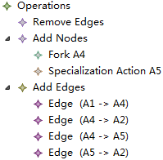

Figure 5 Transformation Rule Operations

For details on the graph transformation interested readers can refer to [1][2]. For details on the graph transformation model structure interested readers can refer to [3].

[1] Andries, Marc, et al. "Graph transformation for specification and programming." Science of Computer programming 34.1 (1999): 1-54.

[2] Heckel, Reiko. "Graph transformation in a nutshell." Electronic notes in theoretical computer science 148.1 (2006): 187-198.

[3] Luo, Xi. “Feature-based Configuration Management of Applications in the Cloud.” Diploma thesis, Technische Universität Dresden, Juni 2013